SCAMPER Template

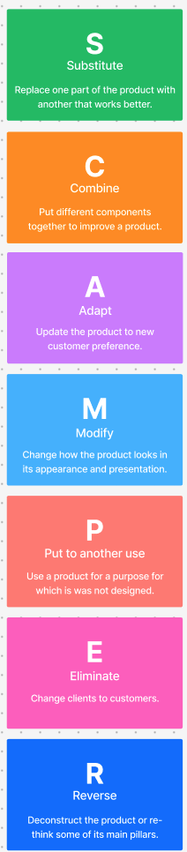 | Replace paper forms, repeated branch visits and manual KYC steps with digital forms, e-KYC, digital document verification and V-CIP where applicable.
 | Combine account application + KYC + verification + account activation + mobile banking setup into one integrated digital journey.
 | Adopt one-click experiences, progress tracking and personalised recommendations from fintech, e-commerce and ride-hailing platforms.
 | Simplify forms, introduce smart forms, progress bars, saved applications, automated updates and AI assistance.
 | Use the bank's customer data, CRM and existing digital infrastructure to personalise product recommendations and proactively offer relevant services.
 | Eliminate duplicate data entry, unnecessary paperwork, repeated document submission and avoidable branch visits.
 | Move from branch-first → digital-first: customer starts online, completes verification remotely, and uses a branch only when human assistance is genuinely required.

